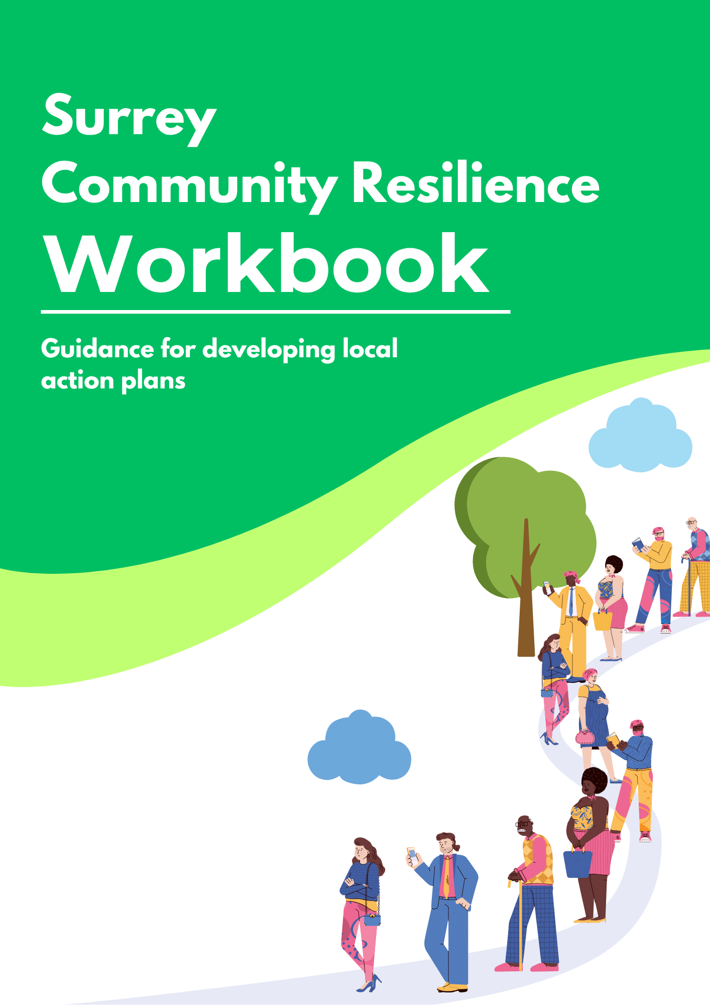

Introduction
This workbook, accompanied by the Surrey Community Resilience Toolkit, sets out how communities in Surrey can prepare for emergencies and reduce the likelihood of their occurrence. It summarises the key risks facing the county and outlines practical actions communities can take both now and in the future. By using both this Workbook and the Toolkit, you will be supported to develop your own local Action Plan – a clear, practical, and community-specific document to strengthen your area’s resilience.
Across Surrey, our emergency services, local authorities, health partners, and the Environment Agency work together in partnership via Surrey Prepared to plan for and respond to major incidents. This partnership is crucial for supporting the development of resilient communities which help to safeguard and support residents in times of need.
Surrey Prepared has identified several significant county-wide risks, many of which are expected to increase due to a combination of ageing infrastructure and accelerating climate change. Their collective work on these identified risks is available as a collection of resources, which are designed to help communities understand their risk level and prioritise their response to best prepare their area to take action.
This resilience planning guidance is structured in two parts:
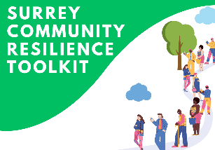
The Community Resilience Toolkit: Provides the overarching context and explains why community preparedness is important, with guidance and supporting resources.
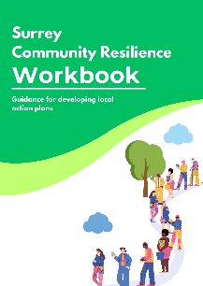
The Workbook (this document): Supports longer-term planning and creating an Action Plan to help communities to build resilience over time and take steps to reduce risk.

Additionally, the Surrey Prepared Community Emergency & Resilience Plan, for Parishes and Town Councils which focuses on short‑term readiness and helping communities prepare for and respond effectively if an incident occurs.
There is no statutory requirement to complete this plan, but it is a useful tool for local emergency planning and for setting up a community emergency hub. It also complements the Action Plan outlined in this workbook. The template can be found in Appendix 2, if you would like to develop one on behalf of your Parish or Town Council, or to find out more, please get in touch: community.resilience@surreycc.gov.uk

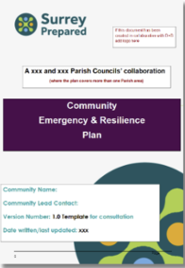

Contents
- Creating an Action Plan 4
ii. Specialist Support 4
iii. Community Resilience Grant 2026 5
- Understanding your Community 6
- Where You Can Have the Biggest Impact 8
3a. Risk & Impact Mapping 8
3b. Carbon Emissions Mapping 9
3c. Nature Mapping 9
- Mapping Tools 14
4a. Surrey Local Nature Recovery Strategy (LNRS) 14
4b. Land App 14
4c. IMPACT 15
- Explore Local Risks 15
5a. Flooding 15
5b. Wildfire 16
5c. Utilities 18
5d. Adverse Weather 18
- Identify Practical Projects 21
- Surrey Resources 22
7a. Setting up a Community Emergency and Information Hub 22
7b. Transport & Travel 23
7c. Food & Waste 23
7d. Land Use & Nature 24
7e. Energy & Homes 24
- Appendix 1 25
Action Plan Template 25
- Appendix 2 32
Surrey Prepared Community Emergency & Resilience Plan 32

1. Creating an Action Plan
This workbook and the accompanying toolkit should be used to support the development of your Action Plan. It includes targeted prompts and activities to help you identify priorities and outline practical actions with the aim of developing impactful projects.
The exercises in this workbook are designed to help you identify and understand the needs specific to your local community and its priorities. Information gathered through the mapping activities should be used to inform your final Action Plan using the template in Appendix 1. Any maps, notes, and supporting evidence can be kept as supporting documentation for your records.
The Action Plan template features a series of tables. A completed Action Plan will show that all the relevant risks and themes within your area have been considered.
For each Action Table:
- Consider the specific risk in the context of each theme (e.g. impact of flooding on transport) and assess its relevance to your area.
- If the risk and theme are relevant, provide details of the actions that will be taken, including ownership and resources required.
- If the risk and theme are not relevant to your area, enter "N/A" and provide a brief explanation outlining why it is not applicable.
All Action Tables should therefore contain either:
- A completed action; or
- N/A with a short justification
On completion of the work, you will have covered four key areas:
Understand Your Community
Where You Can Have the Biggest Impacts
Explore Local Risks
Identify Practical Projects

To support you in the development of your plan, we have made additional resources available:

Specialist Support
Specialist support is available, including expertise in flooding, wildfire, and climate resilience, to help strengthen your Action Plan. Links and contact details for expert advice can be found throughout the workbook.

Community Resilience Grant 2026
To help support you in creating an Action Plan, the Resilience Programme 2026 is offering two stages of grant funding.
  - £1,000 Action Plan Grant
The £1,000 Action Plan grant recognises that it can be difficult for groups to prioritise and resource the completion of an Action Plan. Therefore a £1,000 grant is available to both encourage and support groups through this process. To receive the grant, please complete an Action Plan using the template in Appendix 1. We also encourage you to begin your Surrey Prepared Community Emergency & Resilience Plan which can be found in Appendix 2.
Guidance and resources can be found here. Please send completed Action Plans by email to the Greener Futures inbox at: greenerfutures@surreycc.gov.uk
  - Up to £15,000 Project Delivery Grant
The second stage of grant funding is available to enable groups to act upon the plans they have created. Up to £15,000 is available to deliver one or two impactful projects that have been identified within your Action Plan, through community collaboration.
Need inspiration or support?
On Page 16 you will find example projects to give you an idea on what can be delivered. Support is available at both stages and includes signposting you to existing materials, guidance and resources.

2. Understanding your Community
A community map can be created by marking risks, assets and key contacts on a shared map. Assets may include existing community centres, green spaces or key landowners. The checklist below will help you get started.
Checklist for getting started:
Decide whether you’re mapping collectively or individually
Collective mapping is usually most effective, as it brings in wider knowledge and perspectives from outside your group.
Find out what mapping already exists
Find out if any previous mapping has been done locally. You may be able to use or build on it rather than starting from scratch.
Choose how you want to develop your community map
Pick approaches that suit your community and the people involved, such as:
- Creative activities (diagrams, post-it notes)
- Walk-arounds in the local area
- Desk-based research and conversations
- Facilitated workshops

Set the scene
Start the session with a local example or scenario to help people visualise risk and impact. Real examples work especially well. You could explore questions such as:
- What would happen if the high street or a main road flooded
- How might a fire in a park or key building affect the community
- What would the impact be if there was a power or water outage

Agree how you will come together
Think about the format that works best for your group:
- Will you use an existing meeting or event?
- Do you need to set a specific time and location?
- Are you meeting in person or virtually?

Understanding the Community
Use this space to build a clear picture of your community. Findings identified should be carried forward into your final Action Plan.
- What are the key features of your area? (e.g. farms, industrial areas)

- Who lives and works in your community? (e.g. families, older residents, commuters)

- What important assets exist? (e.g. community centres, schools, green spaces, local groups)

- Are there any known risks or challenges? (e.g. isolation, flooding, limited transport)

- What existing strengths or networks could you build on? (e.g. volunteers, local organisations)

3. Where You Can Have the Biggest Impact
The previous section enabled you to create a simple overview of your community. In this next section you have the opportunity to develop your overview further.
The activities in this section are designed to help you understand your risks locally, explore how nature can reduce impacts, and understand how longer-term mitigation actions (such as emissions reduction) can help to reduce the likelihood of future incidents.
Completing all three exercises will help you identify where you can have the biggest impact and support you in developing an Action Plan by highlighting which projects to prioritise.

3a. Risk & Impact Mapping
Understanding your community’s risks starts with identifying what hazards exist, where they occur, and how severe the impacts could be. Risk and impact mapping helps you pinpoint priority risk areas, understand who or what may be affected, and plan targeted actions to reduce harm.
You should map:
- The type of risk (e.g. flooding, heatwave, wildfire, pollution, storm damage)
- The location of the risk
- The severity or likelihood of the risk
- The people, buildings, infrastructure, or services that could be affected

3b. Carbon Emissions Mapping
Understanding local sources of carbon emissions can help your community identify activities that contribute to climate change and where action could reduce future risks. While emissions are not immediate hazards like flooding or wildfire, they can increase the likelihood and severity of climate-related risks over time.

Mapping emission sources can help you understand how local activities, infrastructure and land uses may be contributing to climate change and health impacts such as poor air quality. It can also help identify opportunities to reduce emissions while strengthening long-term community resilience.
You should map:
- The main sources of carbon emissions in your area
- Where these emission sources are located (e.g. Major roads and junctions, industrial estates)
- How they may link to local environmental pressures or future climate risks
- Opportunities to reduce emissions and strengthen long‑term resilience

3c. Nature Mapping
Once you have identified the main risks in your area, the next step is to map your local assets. These could include parks, trees, rivers, wetlands, ponds, woodlands, green corridors, or other natural and semi-natural spaces.
Features such as rivers, floodplains and forests can help manage risks, for example by slowing water run-off, stabilising soil, cooling built-up areas, or buffering against extreme weather.

Equally, some natural features such as dry scrub or unmanaged vegetation may increase risks, for example by contributing to wildfire spread.
Nature mapping is therefore important for identifying both risks and solutions. You should identify:
- The natural assets present in your area
- Key habitats (e.g. grassland, wetlands, woodland)
- Where these assets are located
- Who owns or manages them, where possible
- What role they currently play in reducing risk or increasing resilience
- Where there are gaps or opportunities to strengthen nature-based protection

Why Use Nature-Based Solutions?
Nature-based solutions use natural systems to reduce risks while delivering wider environmental and community benefits. Compared to traditional approaches, they can offer several advantages:
- They are often more cost-effective than “hard engineering” solutions
- Small changes to existing natural assets can sometimes deliver significant improvements
- Many projects can be implemented or supported by volunteers
- They generally avoid generating additional emissions and can help address some of the root causes of climate-related risks
- They can sequester carbon, with land use change playing an important role in reducing local emissions
- They can improve health outcomes through better air quality and mental wellbeing benefits
- They can provide shading, reduce flood risk, and help reverse biodiversity loss (which in Surrey is above the national average)

Risk & Impact Mapping
Use this space to capture key risks and the impacts in your area. The risks you identify should help determine the priorities and actions included in your final Action Plan.
- What are the main risks affecting your community?

- Where do these risks occur?

- How severe or likely are they?

- Who or what is most at risk (e.g. people, buildings, services)?

- Which risks should be prioritised for action?

Carbon Emissions Mapping
Use this space to identify major sources of emissions and opportunities for reduction. The findings should be used to inform actions and projects included in your final Action Plan.
- What are the main sources of emissions in your area?

- Where are these sources located?

- How might they contribute to environmental or climate risks locally?

- Are there clear opportunities to reduce emissions?

- Which areas should be prioritised for action?

Nature Mapping Prompt
Use this space to explore how nature can reduce risks and support resilience. Any priorities, risks or nature-based solutions identified should be considered in your final Action Plan.

- What natural assets exist in your area (e.g. parks, rivers, woodlands)?

- Where are they located?

- What role do they currently play in reducing risk?

- Are there any natural features that may increase risk?

- Where are the opportunities to strengthen nature-based solutions?

4. Mapping Tools
Below are some tools that can support you in mapping your local area, including risks, natural assets and sources of emissions.

4a. Surrey Local Nature Recovery Strategy (LNRS)
Surrey’s Local Nature Recovery Strategy (LNRS) is a county-wide, spatial strategy that shows where action to restore and enhance nature could have the greatest impact. It can help groups understand where natural assets already exist and where nature-based action may support local resilience.
Groups can use it to:
- Identify areas where restoring or protecting nature may support resilience and environmental improvement
- Explore habitats and opportunity areas in the local area, including safe walking routes and nature corridors etc.
- Consider where nature-based actions, such as tree planting or habitat creation, align with Surrey’s wider priorities
Best used for: Nature Mapping and identifying where nature-based solutions may help reduce risk.

4b. Land App
Land App is a digital mapping platform that helps users map land ownership, habitats and environmental features using drawing tools, data layers and shared maps. It can support groups to build a local nature baseline and create a clearer picture of land use and natural assets.
It has both a free version with core mapping features and a paid version that provides access to more advance tools and data layers.
Groups can use it to:
- Create maps showing boundaries, habitats, important local sites
- Add environmental data layers and explore land use or habitat information
- Customise maps with labels, notes and other details to support local planning and discussion
- Share maps with others to support collaboration and community engagement
Best used for: Nature Mapping, habitat baselining and creating shared local maps.

4c. IMPACT
IMPACT is a community carbon calculator developed by the Centre for Sustainable Energy. It helps groups understand the main sources of emissions in their area and how these may contribute to the wider drivers of climate-related risk over time.
Groups can use it to:
- Identify the main sources of emissions in an area
- Explore whether emissions are linked to housing, transport, energy use, food or waste
- Compare a local area with local or national averages
- Download a report to support planning, engagement and priority setting
Best used for: Emissions Mapping and understanding the root drivers behind longer-term climate and environmental pressures.

5. Explore Local Risks
This section expands on the four risks introduced in the main toolkit, focusing on examples of practical projects your community could develop to help address them. If your area is at risk, the ideas below can make a significant difference and can be actioned by a community group with a small amount of funding. For more information about these risks and the actions Surrey is taking, please look at our website.
Surrey Prepared also provides a range of practical resources covering all nine key risks. To explore these further, please visit their website.
The toolkit also outlines actions you can take to prepare for potential risks and respond effectively if they occur. Included under each risk in this section are examples of projects that can help reduce its impact and strengthen resilience within your community.
Before considering any projects, it is important to refer to your local mapping to understand and identify appropriate locations. Ensure you have the correct permissions in place, particularly from landowners, and that the right people are involved.
We have included some links to further information throughout this section. If you are interested in any of the projects or would like to discuss how you could set one up, please get in touch at greenerfutures@surreycc.gov.uk.


5a. Flooding
How could flooding affect your area?
When most people think about flooding, they might picture rivers and streams bursting their banks. But many Surrey residents are at risk from surface water flooding, and other different types. Surface water flooding is the most common source of property flooding in Surrey, and occurs suddenly, often during heavy summer storms.
First step: Check your flood risk
You can find out if your property is at risk from flooding by visiting the long-term flood risk assessment for locations in England (GOV.UK) page.
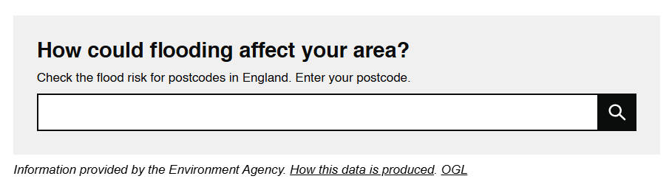

You can find more information about flooding and guidance on the Surrey website or click here.
If your area is at risk, the community projects below can help make a difference by slowing down rainwater, improving drainage, and reducing pressure on local systems.
Community projects to reduce flood risks:
Sustainable Drainage Systems (SuDS Planters)
Install planters that capture and slowly release rainwater, reducing the risk of overload during heavy rainfall.
Tree planting and woodland creation
Trees help manage rainfall by improving soil structure and slowing runoff. When carefully planned and delivered, even small planting projects can contribute to flood risk reduction.


5b. Wildfire
Be prepared for wildfires
During prolonged dry, warm, or windy conditions, vegetation such as heathland, grassland and woodland can become highly flammable, allowing fires to spread quickly. Surrey is particularly susceptible to wildfires due to its large areas of heathland and open countryside - including commons, nature reserves and green spaces close to towns and villages.
Many wildfires start accidentally often from discarded lit cigarettes, glass, barbecues, bonfires, campfires or even sparks from machinery.
First step: Understanding local risks
Wildfire risk varies depending on local land use, vegetation, weather conditions, and human behaviour. Areas near heathland, woodland or unmanaged grassland may be more vulnerable, particularly during extended dry spells.
You can find information on environmental risks and severe weather guidance including wildfire‑related advice through Surrey County Council and local fire and rescue services.
Surrey Fire and Rescue Service also provide further tools, guidance and practical advice to help communities and land managers prepare for and reduce wildfire risks.
Find out more and take action
For any further questions, please contact them at sfrs.wildfire@surreycc.gov.uk.
Community projects to reduce wildfire risk:
Vegetation management and maintenance
Regular cutting, grazing or removal of dry vegetation helps reduce the amount of fuel available for fires, particularly on heathland, verges and open spaces near homes.
Tree and landscape planning
Planting a mix of fire-resilient species and maintaining healthy green spaces can reduce fire spread, improve soil moisture retention and support biodiversity. Contact us and we will point you in the right direction greenerfutures@surreycc.gov.uk and sfrs.wildfire@surreycc.gov.uk.
Community awareness and signage
Information boards and seasonal warnings can encourage responsible behaviour, such as avoiding disposable barbecues or open flames during high‑risk periods. Both SFRS and Surrey Prepared already have messaging, signage and toolkits that you can use or adapt, rather than creating new materials. Contact: community.resilience@surreycc.gov.uk or sfrs.wildfire@surreycc.gov.uk.
If your group or Parish owns or manages publicly accessible land
Please consider the following actions to support wildfire preparedness:
- Provide relevant contact information (including out-of-hours details if available) to Surrey Fire and Rescue Service contactfire@surreycc.gov.uk
- Share site plans and maps, including SSSI (Sites of Special Scientific Interest), boundaries, equipment locations and any resources that may assist
- Where feasible, manage vegetation to help reduce fire spread
- Ensure vehicle access is maintained across the site
- Remove dead or overhanging trees to reduce “ladder fuels” and the risk of canopy fires
- Keep all access points unobstructed and clearly marked


5c. Utilities
Be prepared for utilities outages.
Utilities such as electricity, gas, water, drainage and telecommunications can be vulnerable to extreme and unpredictable weather. In Surrey, adverse weather is increasingly causing short‑term disruptions and longer‑term strain on local utility networks.
First step: Understanding local vulnerabilities
Whilst utilities are managed by service providers, community led action can play a supporting role in reducing pressure on systems and improving local resilience, especially during periods of extreme weather.
Find out more and take action
Community projects to prepare for utilities outages:
Signposting to the Priority Services Register (PSR)
Raising awareness of the Priority Services Register (PSR) and helping people to sign up can ensure vulnerable residents receive extra support from utility providers during power cuts or other disruptions.
Tree management near infrastructure
Community‑led monitoring and responsible planting help prevent damage to power lines, drains and underground services during storms or high winds.
Local resilience and preparedness initiatives
Neighbourhood plans, community support networks and shared information can help residents prepare for short‑term disruptions to power, water or communications.


5d. Adverse Weather
Adverse Weather can affect communities in Surrey in different ways.
We might see more frequent heatwaves, intense rainfall, heavy snowfall, high winds and dry spells over the coming decades. These can disrupt daily life, damage property and place pressure on local services.
The impacts we might see are:
- Overheating in homes, schools and care settings during hot weather
- Surface water, pooling on roads and public spaces after heavy rain
- Damage to trees, buildings and power supplies during storms and high winds
- Dry ground and dry green spaces following prolonged warm or dry periods
- Travel disruption, especially on local roads and rail routes
Climate change means that extreme weather events are likely to become more intense, more frequent, and less predictable. To protect lives and property, local awareness and preparation are crucial.
First step: Understanding local risks
Adverse weather risks vary by location and surroundings. Understanding your local risks can help you plan ahead, protect buildings and green spaces, and support wider community resilience.
Find out more and take action
Community projects to prepare for adverse weather:
Warm hubs in cold spells
Winter Advice
Heated community centres, libraries or village halls offering a place to stay warm, charge devices, access hot drinks and connect with neighbours during severe cold or energy disruptions. Between November and March, Warm Welcome venues are open across Surrey, find a warm welcome venue near you.
Cool hubs during heatwaves
Summer Advice
Air-conditioned or naturally cool public buildings can give people a safe place to escape the heat, get water, and get advice. But travelling in very hot weather can be risky, so it is important to think about whether the location is close and easy to reach. In some cases, it may be safer to encourage people to stay at home instead. If staying at home, simple steps such as keeping curtains or blinds closed during the day, opening windows when it is cooler (for example at night), staying hydrated, and avoiding excess alcohol, caffeine, and/or strenuous activity can help keep indoor spaces, and yourself, cooler.
Neighbour Check-in Networks
Set up simple phone or WhatsApp groups to share timely information and to check-in on neighbours during heatwaves, cold snaps, or storms.
Emergency Information Boards
Use noticeboards or digital channels to share weather warnings, local support, and emergency contacts.
Water efficiency and rain capture
Installing water‑butts, rain capture systems, SuDS planters and water‑efficient planting can reduce pressure on mains water supplies during dry or hot periods.
Grit Bins for Ice and Snow
Grit bins help keep paths and roads safer in icy weather. Use grit on busy or high-risk areas like pavements, steps, and entrances, and use it sparingly. Avoid unnecessary travel where possible and check your nearest grit bin location in advance.
Local organisations can request a new grit bin if needed. For more information and to apply, please look at our website.

6. Identify Practical Projects
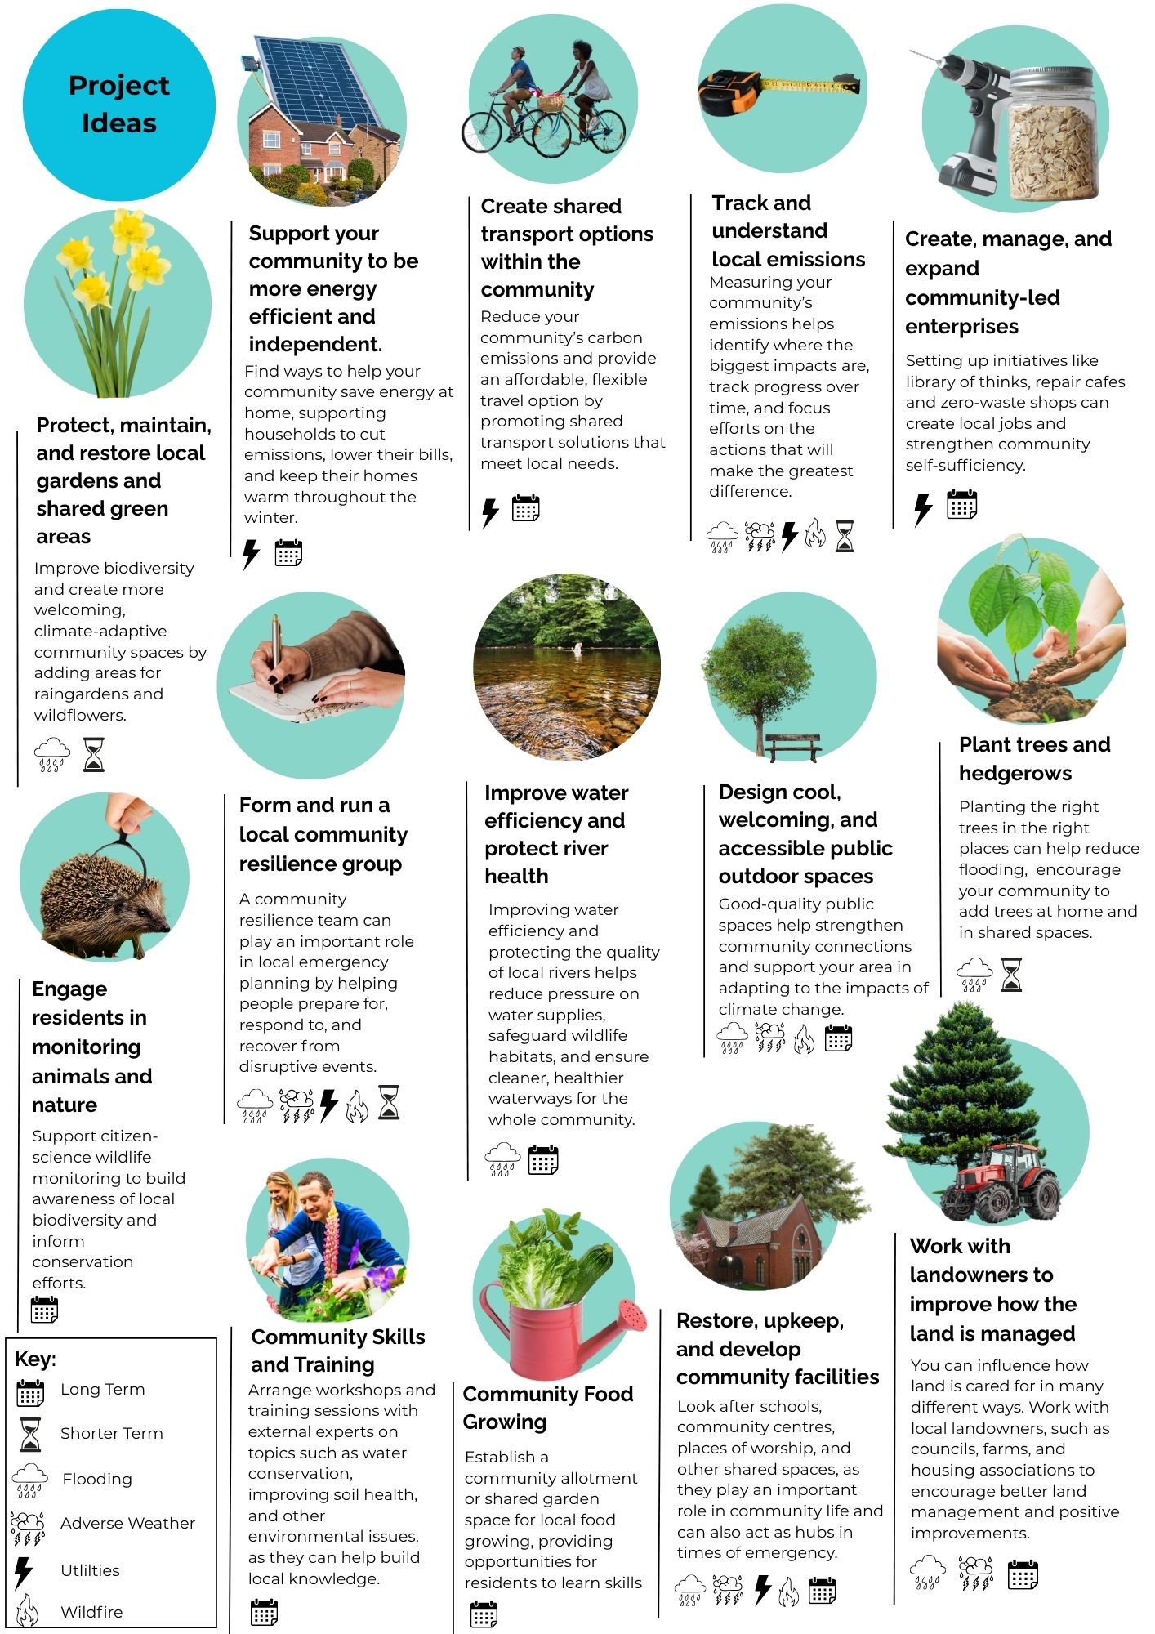

7. Surrey Resources
Below is a selection of project ideas, along with some resources that communities can use to guide action in your area. Some opportunities are specific to Surrey and may come with additional support or materials. Please note that if you have downloaded this template, certain offers may only run at specific times or may no longer be active. To check what is currently available, please visit our main website or get in touch with us.

7a. Setting up a Community Emergency and Information Hub
What can you do?
- Use Surrey Prepared Community Resilience webpages to understand the first steps in setting up a Community Emergency & Information Hub.
- Share SCC’s Emergency Planning guidance with your group so everyone understands what a hub is for and how it supports the community during an incident.
- Start completing the early sections of the Surrey Prepared Community Emergency & Resilience Plan template, including risk mapping, key contacts and local assets.
- Promote SCC’s Preparing for Emergencies resources to residents, including household preparedness tips, checklists and local alert information.
- Connect with your local Borough/District Emergency Planning team for advice, examples and practical support.
- Identify a suitable location for a hub (e.g., village hall, community centre) and begin gathering basic information on access, equipment and volunteers.
Priority actions example:
Short term:
- Begin your Surrey Prepared Community Emergency & Resilience Plan using SCC’s template, share SCC preparedness resources locally.
- Identify a suitable location for the hub.
Long term:
- Develop your hub into a fully functioning community asset, build volunteer capacity, and embed emergency preparedness into wider community plans.
If you’d like to explore this further and find out more about setting up a hub, please contact: community.resilience@surreycc.gov.uk

7b. Transport & Travel
What can you do?
- Promote on-demand buses (e.g. Surrey Connect) as a flexible alternative to car use and for areas that might not have well connected transport links.
- Encourage residents to use BetterPoints Surrey, which rewards walking, cycling and use public transport.
- Support EV uptake by helping identify public charging locations and sharing Surrey’s EV map.
- Promote cycling and active travel, including free Bikeability training for children and adults.
Priority actions example:
- Short term: Promote on-demand buses, BetterPoints, cycle training, Car Club and EV ChargePoint suggestions.
- Long term: Support EV infrastructure and embed sustainable travel in local plans.

7c. Food & Waste
What can you do?
- Encourage food waste reduction and composting (home or community-based).
- Promote reuse, including library of things (Many Surrey Libraries host them), repair groups, swapping events, and online sharing groups.
- Support zero-waste and refill options and reduce waste at community events.
- Promote community fridges and food-sharing schemes to cut waste and support food security.
Priority actions example:
- Short term: Share composting tips, promote reuse and repair, reduce event waste.
- Long term: Support repair groups, community composting and community fridges, embed waste reduction into local plans, and advocate for food waste collections to be provided for all buildings, including flats.

7d. Land Use & Nature
What can you do?
- Protect and monitor local waterways through volunteering and citizen science.
- Encourage citizen science (recording or monitoring species such as pollinators, birds, butterflies) to track change.
- Promote tree planting, including Surrey’s free tree schemes.
- Reduce mowing where possible and create rewilding zones.
- Create a simple nature baseline by mapping habitats and recording actions.
Priority actions example:
- Short term: Promote tree giveaways and nature monitoring.
- Long term: Develop nature projects that align with county‑level LNRS priorities and report progress to contribute to wider monitoring and measurement.

7e. Energy & Homes
What can you do?
- Promote the Surrey Warm Homes grant to help eligible residents access free or subsidised insulation, heating upgrades, and energy-saving measures.
- Signpost households to any local HEAT (Home Energy Advice Team) services to explore in person energy advise, thermal imaging surveys at home, and access to remedial measures for quick wins.
- Support residents to carry out simple home energy checks and signpost them to trusted advice services.
- Map local housing types to understand common issues (e.g. solid walls, off-gas homes) and target projects more effectively.
Priority actions example
- Short term: Promote the Surrey Warm Homes grant, encourage sign-ups to Community HEAT, and share simple energy-saving advice with residents.
- Long term: Work with partners to develop a community-wide home energy improvement plan, support residents through retrofit projects, and track reductions in energy use and emissions.

8. Appendix 1

Action Plan Template
Action Plan Details
Organisation / Group:
Stakeholders involved:
Lead contact:
Plan Review date:

Objectives – What is the aim of your plan? Add more rows if required
1
2
3

Current Position (Baseline)
Summarise your starting point:
- Key issues, risks or challenges:
- Current performance (e.g. emissions, waste, biodiversity, existing projects):
- Opportunities identified:

Understanding the Community
Use this space to build a clear picture of your community:
- What are the key features of your area? (e.g. farms, industrial areas)

- Who lives and works in your community? (e.g. families, older residents, commuters)

- What important assets exist? (e.g. community centres, schools, green spaces, local groups)

- Are there any known risks or challenges? (e.g. isolation, flooding, limited transport)

- What existing strengths or networks could you build on? (e.g. volunteers, local organisations)

Carbon Emissions Mapping
Use this space to identify sources of emissions and related pressures:
- What are the main sources of emissions in your area?

- Where are these sources located?

- How might they contribute to environmental or climate risks locally?

- Are there clear opportunities to reduce emissions?

- Which areas should be prioritised for action?

Nature Mapping
Use this space to explore how nature can reduce risks and support resilience:
- What natural assets exist in your area (e.g. parks, rivers, woodlands)?

- Where are they located?

- What role do they currently play in reducing risk?

- Are there any natural features that may increase risk?

- Where are the opportunities to strengthen nature-based solutions?

Use the below Action Table to consider each of your actions. The first gives a description of what should be included in each box, and the second Action Table gives an example.
Action 1 - Explanation
Risk | Select from flood, wildfire, utilities outages and adverse weather
Theme | Insert relevant theme/s e.g.  - Biodiversity / Nature Recovery  - Community Resilience / Cost of Living  - Energy Resilience  - Food Security  - Transport  - Waste & Resources
Action | Outline what you would like to do
Target audience / beneficiaries | Who will benefit from this action
Outcome | - Carbon reduction  - Nature / biodiversity improvements  - Waste or resource improvements  - Community or wider benefits  - Measurable outcomes or intended metrics
Funding & Resources | Consider different ways this could be financially supported, and note any resources or contacts who could help you with delivery
Impact rating 0-5  (0= not impactful, 5 = highest impact) | Score from 0-5 depending on the estimated impact
Steps | Owner | Deadline | Monitoring
Breakdown of the action into tasks | Who will be responsible for completing the task | When should the task be completed by | - Key measures / indicators  - Reporting frequency  - Review process

Example
Action 2 - example
Risk | Flooding
Theme | Transport
Action | Create map of alternative travel routes, including walking
Target audience / beneficiaries | Commuters, people on school run, other residents travelling around
Outcome | Greater awareness and engagement with alternative routes, including some active travel
Funding & Resources | SCC Grant  Joe Bloggs in village has background in transport  GIS Maps of Surrey: Surrey Interactive Map  Flood Risk Maps: Technical map - Check your long term flood risk - GOV.UK
Impact rating 0-5  (0= least impactful, 5 = highest impact) | 3
Steps | Owner | Deadline | Monitoring
- Research existing maps and flooding hotspots  - Create a map showing alternative routes  - Share map via newsletters, community WhatsApp groups, social media  - Print off physical copies for those without access to the internet | Anne Brown  Chris Dunn  Elizabeth Foy  Anne Brown | Sept 2026  Oct 2026  Nov 2026  Jan 2026 | Check / update map at least annually

Complete the Action Table below as many times as required.
Please note, a completed Action Plan comprises of all relevant risks and themes in your area being considered. If you have considered a theme and risk and deemed it irrelevant to your area, please write N/A with a brief explanation as to why.
Action 1 -
Risk
Theme
Action
Target audience / beneficiaries
Outcome
Funding & Resources
Impact rating 0-5
(0= not impactful, 5 = highest impact)
Steps | Owner | Deadline | Monitoring

9. Appendix 2

Surrey Prepared Community Emergency & Resilience Plan
You should also consider whether your community would benefit from a Surrey Prepared Community Emergency & Resilience Plan. While these plans are not a statutory requirement, many communities find them helpful for organising local information, identifying risks and improving preparedness.
Parish or Town Councils usually lead on these plans due to their role and formal escalation routes during incidents. If your group sits within a parish area, work with the Parish or Town Council rather than creating a duplicate plan if one already exists.
If you are in an area without a Parish, you can still develop a plan. If you’d like to explore this further, please contact community.resilience@surreycc.gov.uk.
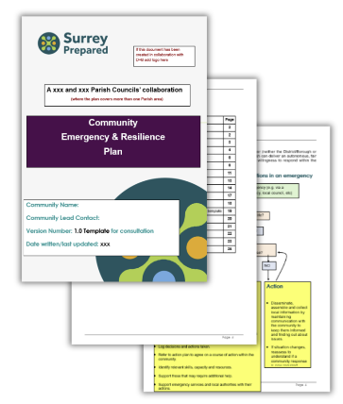
This Community Emergency & Resilience Plan complements, but does not replace, formal emergency planning. Even where a Parish or Town Council leads on emergency response planning, community groups play an important role in strengthening local preparedness and resilience.
A clear emergency response plan helps your community to:
- Know what to do in an emergency
- Understand roles and responsibilities
- Communicate quickly and clearly
- Support vulnerable residents
Find out more about emergency response planning Surrey Prepared.

